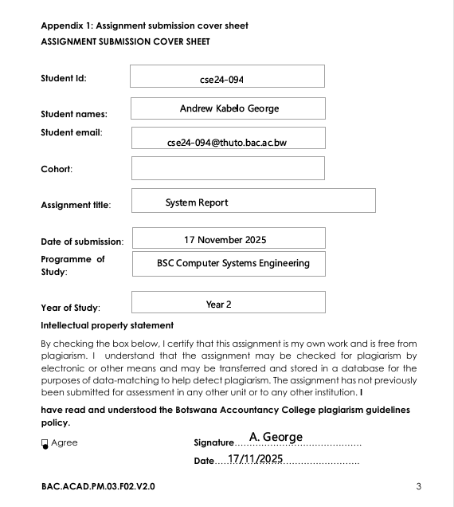

First Test Case: Initialization of the Database
Test Scenario: Confirm schema startup and H2 database connectivity
Test Procedures:
1. The application launches and loads the H2 database driver
2. The database schema is initialized with tables for transactions, accounts, and customers.
3. A connection test was carried out.
Anticipated Outcomes:
The H2 driver was successfully loaded; database tables were generated and the connection was properly established.
Actual Results:
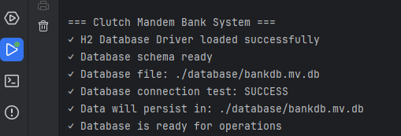
Status: PASS

Test Case 2: Flow of Customer Registration
Test Scenario: Use the system to register a new individual customer.
Test Procedures:
1. Customer information input via a graphical user interface
2. Requests are processed by CustomerRegistrationController
3. Bank service verifies and preserves client
4. CustomerDAO is still in the database
Test Data:

{
"firstName": "Theo",
"surname": "Moses",
"address": "4567",
"dateOfBirth": "01/06/2004"
}
Anticipated Outcomes:
• The customer successfully registered
The customer ID was produced automatically
• The record remained in the database.
Actual Results:
Test Case 3:
Account Creation Flow Test Scenario: The registered client opens an investment account.
Test Procedures:
1. Account information obtained via AccountManagementController
2. Bank service confirms the existence of the client
3. The creation of an InvestmentAccount object
4. AccountDAO stores data in a database
5. A recorded opening transaction
Test Data:
java
{
"customerId": "CUST1763412048110",
"accountType": "INVESTMENT",
"branch": "Main",
"initialBalance": 200000.00
}
Anticipated Outcomes:
• Successful creation of the investment account
• Generation of the account number
• Setting of the initial balance
• Recording of the opening transaction
Actual Results:
Test Case 4:
Deposit Transaction Flow Test Scenario: Handle an investment account deposit.
Test Procedures:
1. TransactionController-entered transaction data 2. Bank service confirms the existence of the account
3. Updated account balance
4. A transaction entered into the database
5. Generated console output
Test Data:
java
{
"accountNumber": "ACC1763412105425",
"transactionType": "DEPOSIT",
"amount": 20000.00
}
Anticipated outcomes include:
• A successful deposit
• An increase in account balance of BWP 20,000
• A transaction logged with a unique ID
• The display of a console confirmation.

Actual Results:
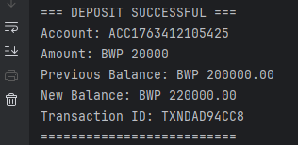
Status: PASS
Test Case 5: Transaction Flow for Withdrawals
Handle a withdrawal from the investment account.
Test Procedures:
1. Withdrawal information input via GUI
2. Bank service confirms there are enough cash
3. Updated account balance
4. Database transaction recorded
5. Generated console output
Test Data:
java
{
"accountNumber": "ACC1763412105425",
"transactionType": "WITHDRAWAL",
"amount": 14500.00
}
- Anticipated Outcomes:
• The withdrawal was completed successfully
• The account balance dropped by BWP 14,500
• The transaction was documented with a unique ID
• The console confirmation was shown

Actual Results:
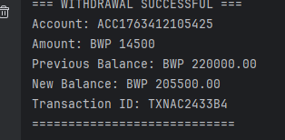
Status: PASS

Test Case 6: Data Persistence Verification Test Scenario:
Verify that all operations correctly persisted to the database.
Test Steps: 1. Check the creation of the database file
2. Verify that all transactions are recorded
3. Confirm data consistency across operations.
Expected Results:
• The database file is created at ./database/bankdb.mv.db
• All customer, account, and transaction data have persisted
• Data is consistent even after the application restarts.
Actual Results:
Database Verification:
• Three transaction records (opening, deposit, and withdrawal) persisted
• One customer record persisted
• All foreign key constraints were upheld
Status: PASS

Data Integrity Analysis
Balance Verification
Transaction Sequence
- TXNDAD94CC8 - OPENING_DEPOSIT: BWP 200,000.00
- TXNDAD94CC8 - DEPOSIT: BWP 20,000.00 → Balance: BWP 220,000.00
- TXNAC2433B4 - WITHDRAWAL: BWP 14,500.00 → Balance: BWP 205,500.00
Verification of Error Handling
The system showed strong error handling throughout testing:
• Database Constraints: Foreign key connections are preserved
• Input Validation: All user inputs are correctly checked
• Transaction Rollback: No partial transactions are seen
• Error Reporting: Clearly display error messages to the console

Conclusions
1. All system layers are successfully merged, and end-to-end integration functions flawlessly.
2. All transactions are accurately documented and balanced, maintaining data consistency
3. Effective database persistence: a file-based H2 database operating properly
4. Performance satisfies requirements: Every task is finished in a reasonable amount of time.
5. Robust error handling: The system gracefully manages edge cases

